No other colleges offer a baccalaureate in Avionics in California. Antelope Valley, although not in commuting distance, offers a bachelor’s degree in Airframe Manufacturing:

AFMT Program Description: AVC's Airframe Manufacturing Technology Program (AFMT) is designed to meet the need in the aerospace industry for multi-skilled individuals who understand, perform, and serve as first-line leads in the major processes of manufacturing the structural components of an aircraft for civilian and military specifications. The program's curriculum addresses airframe manufacturing, aircraft fabrication (structures and composites), and electronics.
The AFMT Bachelor's Degree Program is a one-of-a-kind program specifically designed to meet aerospace industry needs for individuals who serve as first-line leads in the major processes of aircraft manufacturing, with a focus on manufacturing and industrial engineering. The AFMT Bachelor's program is geared toward students who have completed or are in progress of completing a two-year program in Aircraft Fabrication and Assembly, and who are interested in pursuing a bachelor's degree in Aircraft Manufacturing Technology. Students will enter directly as juniors (3rd-year track students).
To ensure our program was non-duplicative of any state-wide offerings, we conducted extensive research into all similar programs in our region and across California. After determining the appropriate Standard Occupational Code (SOC) and Classification of Instructional Programs (CIP) code based on employer feedback, we used these codes to identify related programs. We further undertook a detailed review of the curriculum of all potentially similar programs, which involved comparison of program learning outcomes, course descriptions, and course learning outcomes. Finally, we consulted with faculty and administrators of identified aviation programs.

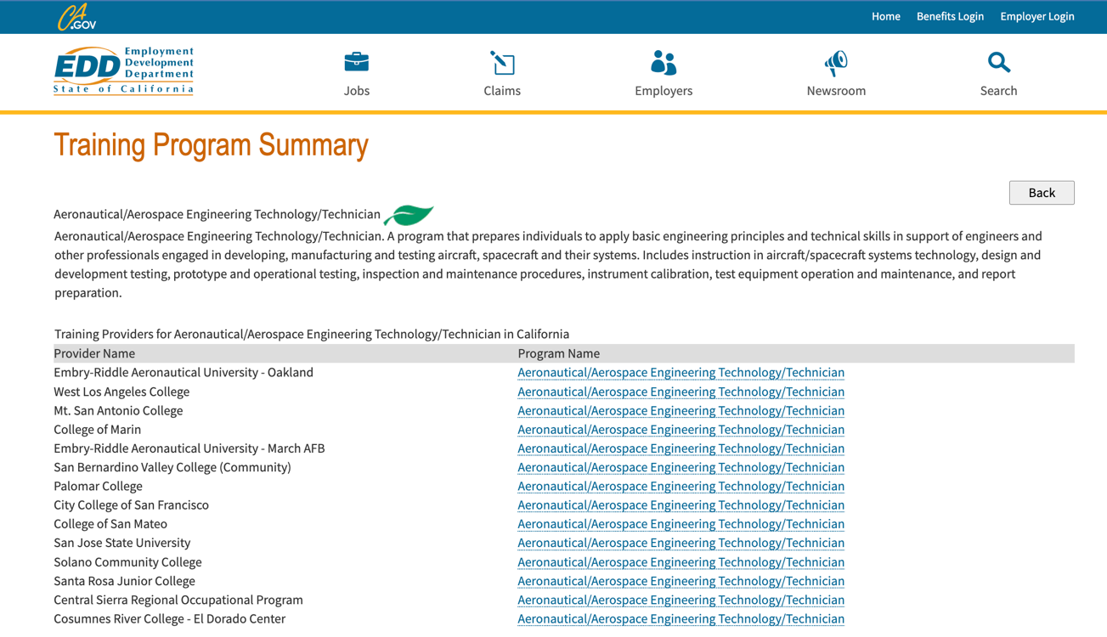
The majority of programs are either community colleges programs offering certificate programs or private institutions (such as Embry Riddle). The only UC/CSU system program listed is at San Jose State. Their program is a 2+2 model that accepts graduates of external 2-year FAA-certified Part 147 Airframe and Powerplant (A&P) programs as transfers into their Bachelor of Science in Aviation Maintenance Management. However, the upper-division coursework for that program is in management, with no technology courses or training in avionics.

